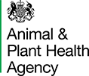 | Important Notice: Avian Influenza (Bird Flu) Case Near Claydon Mid Suffolk | 
Attention Resident:
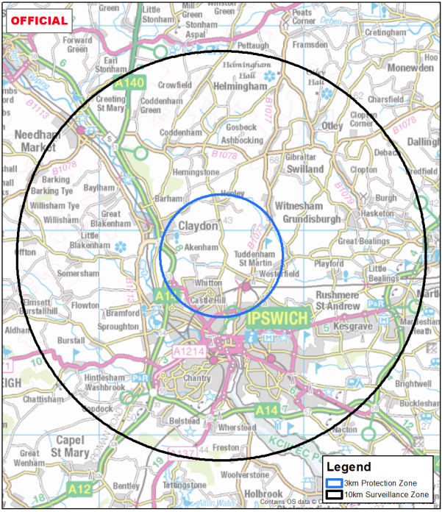
Highly Pathogenic Avian Influenza has been confirmed at premises near to Claydon Mid Suffolk and the Government has declared:

A 3km Protection Zone and a 10km Surveillance Zone.
Controls include the housing of all kept birds within the 3km Protection Zone and the need for all kept bird movements to be licenced within both zones.
The declaration containing the full rules can be accessed by scanning the QR code above.
APHA staff will contact registered poultry/captive bird keepers within the Protection Zone as (shown by the blue circle) to gather information that will help veterinary staff assess the risk of avian influenza spread. APHA veterinary staff may need to carry out an inspection of your birds to assess their health. However, kept birds will only be culled if Avian Influenza is confirmed in a flock following laboratory testing of samples, or if veterinary risk assessment indicates any significant links to an infected premises.

Further information on the latest avian influenza restrictions together with extensive guidance on bio security measures ‘including housing’ can be found by typing https://www.gov.uk/government/news/bird-flu-avian-influenza-latest-situation-in-england into your browser or by scanning this QR code.

In response to new disease outbreaks, control zones may sometimes change, and keepers may be affected by multiple zones with different sets of rules. As such keepers of kept birds must ensure they keep up to date with the latest rules that may apply to them.

The risk to public health from the virus is very low, however it is important that people don’t pick up sick or dead birds.

Poultry Registration - Compulsory registration of poultry and captive birds within England has been required since 1st October 2024 and if you keep poultry or captive birds and have not registered them, you must do so via an online form at: www.gov.uk/guidance/register-as-a-keeper-of-less-than-50-poultry-or-other-captive-birds. Poultry keepers can also e-mail customer.registration@apha.gov.uk or phone: 03000 200 301 if more support is required.

Signs of Avian Influenza - If your birds become ill, consult your vet immediately. Avian Influenza spreads through direct contact or contaminated fluids and faeces. Symptoms in poultry include:
- Swollen head and blue discolouration of the neck and throat
- Loss of appetite and diarrhoea
- Respiratory distress (gaping beak, coughing, sneezing, gurgling, rattling)
- Reduced egg production and increased mortality

By law, if you or any suspicion of disease must be immediately reported to APHA by telephoning
03000 200 301.

Wild Birds - No action is required for wild birds, however, you can assist by reporting dead wild waterfowl (swans, geese, ducks) or other wild birds (gulls, birds of prey) to the Defra online at https://www.gov.uk/guidance/report-dead-wild-birds or call the helpline on 03459 335577.

