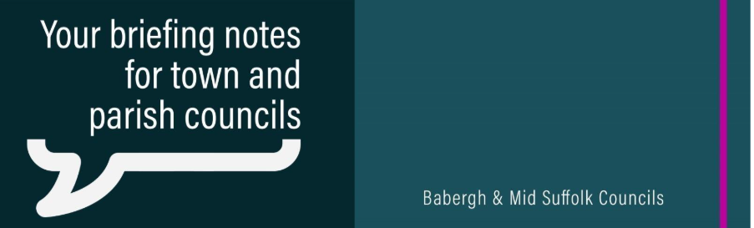

Local elections: 7 May
Next Thursday, polls across the county will open from 7am to 10pm for residents to vote in local elections. In Babergh, residents will be able to vote for their next Suffolk County Councillor. Results will be promoted by Suffolk County Council via their website and social media channels. In the meantime, relevant information remains on the Babergh District Council website and we will continue to promote this to residents via our Facebook page.

New recycling collections in Suffolk less than six weeks away
From the end of next week, residents will begin to receive an information pack which includes details on what items can be put in each of their bins in preparation for the new service starting on 1 June. You can find digital versions of the information packs on the Suffolk Recycles website and attached to this email. We are continuing to promote Better Recycling across our social media channels.

Developer faces £146k bill after failing to pay levy for community
A district judge has ordered a business to pay a total of £146k after it built homes without making any contribution towards local facilities.

